Assignment# 4

Linear Regression: House Rent Prediction


Advance Stats
Submitted by: Jawad Hassan, Nimra Siraj
Roll No: 2230-0035,2530-4028

Submitted to:
Dr. Sana
DATE:
3 November 2025

Table of Contents

Introduction

Problem Statement and Objectives

Data and Preprocessing

Iterations and Code Run

Results Summary

Discussion

Conclusions

1. Introduction
The project focuses on predicting house rent prices using machine learning, report implements and explains multivariate linear regression on the Brazilian Houses Dataset, from first principles using explicit summed gradients that match the lecture notation in s θ₀, θ₁, θ3… form. Two solution approaches are compared: batch gradient descent (with simultaneous updates) and the closed-form normal equation. Rent prices depend on multiple factors like city, rooms, bathrooms, furniture, and insurance. The goal is to estimate rent accurately and understand which features influence rent the most. The Python implementation (NumPy/ pandas/sklearn/matplot) is included and presented using listings for reproducibility. Following equations were used for linear regression:

2. Problem Statement and Objectives
Problem:
Predict house rent (y) from measured multiple features house size, city, rooms, furniture (x1, x2, x3…) using multivariate linear regression.
The model is trained using a labeled dataset of historical rental information. The performance is evaluated through Mean Squared Error (MSE) to determine how well the regression model generalizes to unseen data.
Ultimately, this project demonstrates how multivariate linear regression can be used to make data-driven predictions about real estate rental prices based on multiple influential features.

Objectives:
- Implement the hypothesis h_θ(x) = θ₀ + θ₁x.
- Implement the cost function J(θ₀, θ₁).
- Compute explicit summed gradients (first principles) and apply batch gradient descent (simultaneous updates).
- Compute closed-form solution using the normal equation for comparison.
- Produce per-example diagnostics to show terms used in the gradient sums.

Aim:

Build a regression model that minimizes prediction error and explains rent variation.

Preprocess the dataset and encode categorical data.

Train a multivariate linear regression model for rent prediction.

Evaluate model performance using:

Mean Squared Error (MSE)

Visualize results with scatter plots and regression lines.

Analyze how each factor impacts rent prediction accuracy.

3. Results and Discussion

Data and Preprocessing
- Read CSV via pandas.read_csv.
- Auto-select numeric columns if names differ.
- Remove rows with missing values.
- Set m equal to number of valid examples.

Data and Preprocessing
Data was taken from kaggle in csv file(6080 tuples):
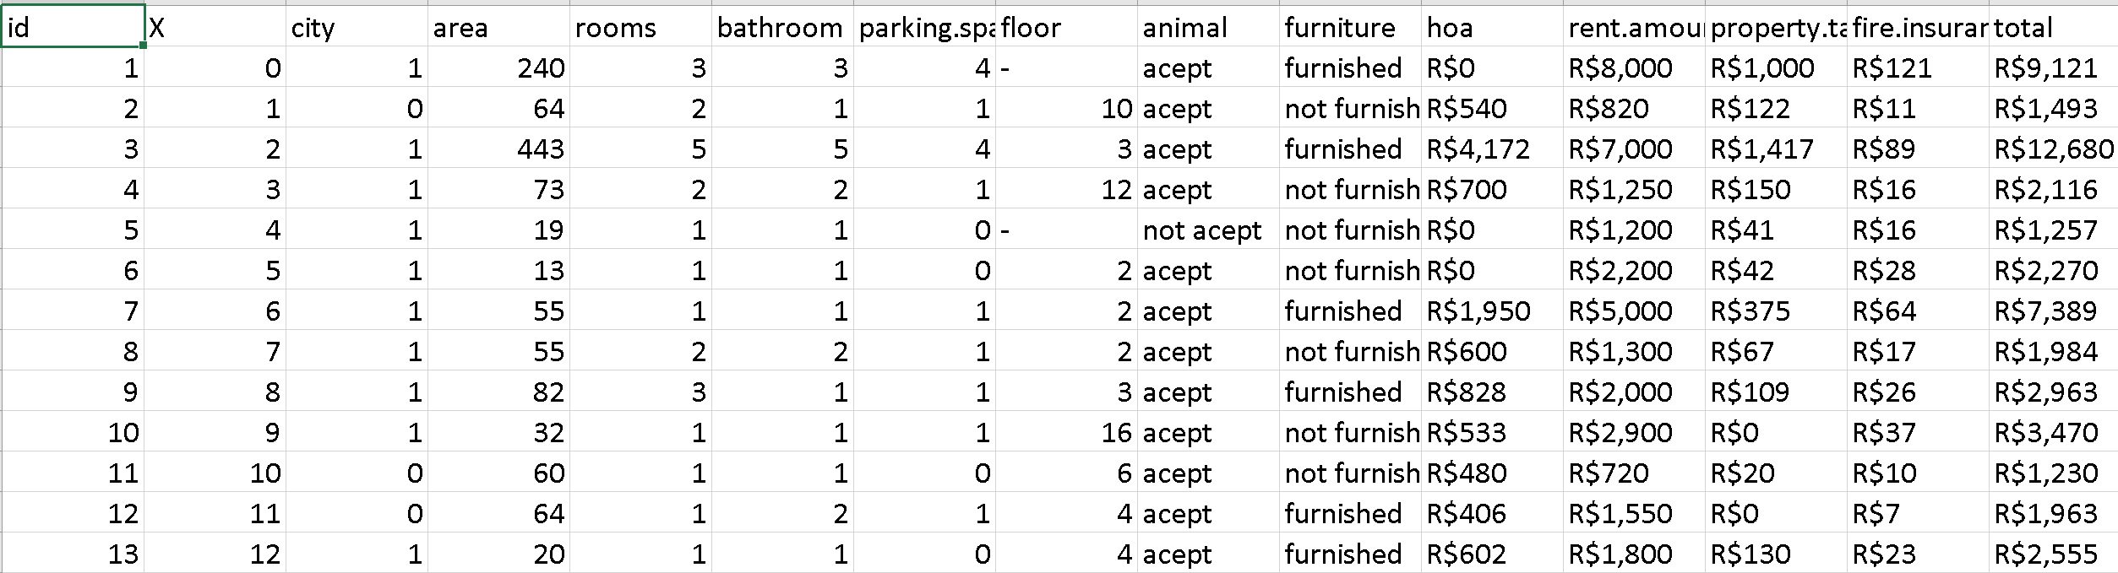

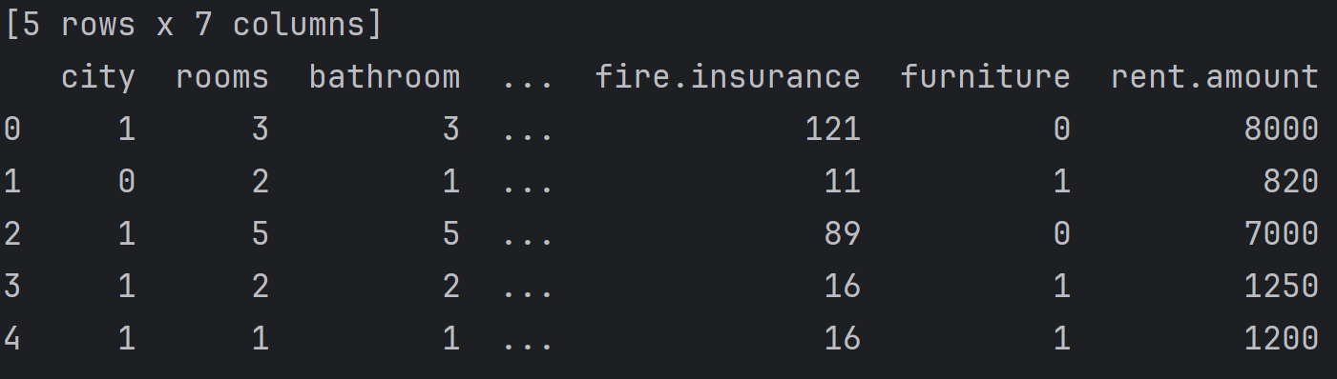

Code:
import pandas as pd
from PIL.GimpGradientFile import linear
from sklearn import preprocessing,model_selection,linear_model,metrics
import numpy as np
import matplotlib.pyplot as plt
#load data
print('-'*30);print('importing data');print('-'*30)
data=pd.read_csv('brazilianhouses.csv',sep=',')
data=data[['city','rooms','bathroom','parking.spaces','fire.insurance',
'furniture','rent.amount']]
print(data.head())
#process data
data['rent.amount']=data['rent.amount'].map(lambda i:int(i[2:].replace(',','')))
data['fire.insurance']=data['fire.insurance'].map(lambda i:int(i[2:].replace(',','')))
le=preprocessing.LabelEncoder()
data['furniture']=le.fit_transform(data['furniture'])
print(data.head())
print('-'*30);print('checking null data');print('-'*30)
print(data.isnull().sum ())
#data=data.dropna()
#split data
x=np.array(data.drop(['rent.amount'],axis=1))
y=np.array(data[['rent.amount']])
print(x.shape)
print(y.shape)
xtrain,xtest,ytrain,ytest=model_selection.train_test_split(x,y,test_size=0.2)
print(xtrain.shape)
print(xtest.shape)
#trainning
print('-'*30);print('trainning data');print('-'*30)
model= linear_model.LinearRegression()
model.fit(xtrain,ytrain)
accuracy=model.score(xtest,ytest)
print("coefficients:",model.coef_)
print("intercept:",model.intercept_)
print('accuracy:',round(accuracy*100,2),'%')
##evaluation
print('-'*30);print('evaluation');print('-'*30)
ypred=model.predict(xtest)
print(ypred.shape)
error=[]
for i,test in enumerate(ypred):
error.append(ytest[i]-test)
print('actual:',ytest[i],' predicion:',int(test),' error:',int(error[i]))
# Mean Squared Error
mse = metrics.mean_squared_error(ytest, ypred)
print("Mean Squared Error:", round(mse, 2))
# -----------------------------
# Plot results
# -----------------------------
plt.figure(figsize=(8,6))
plt.scatter(ytest, ypred, color='blue', alpha=0.6, label='Predicted vs Actual')
plt.plot([ytest.min(), ytest.max()], [ytest.min(), ytest.max()], color='red', linewidth=2, label='Ideal Fit (y=x)')
plt.title('Actual vs Predicted Rent Amounts')
plt.xlabel('Actual Rent Amount')
plt.ylabel('Predicted Rent Amount')
plt.legend()
plt.grid(True)
plt.show()

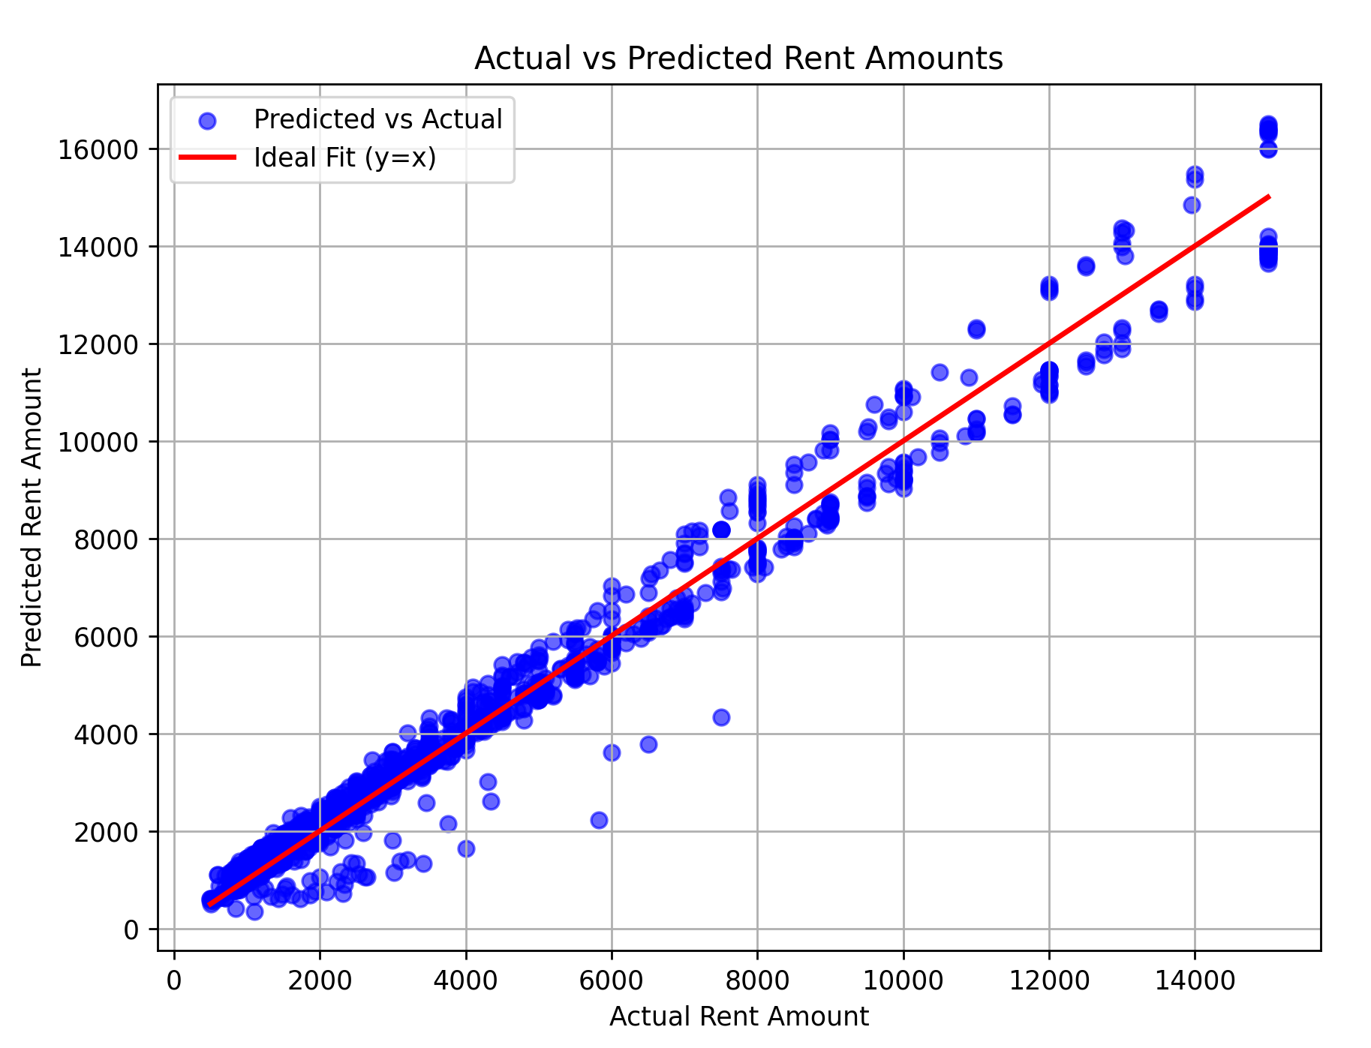  Fig.1 Training Data with Regression Lines | 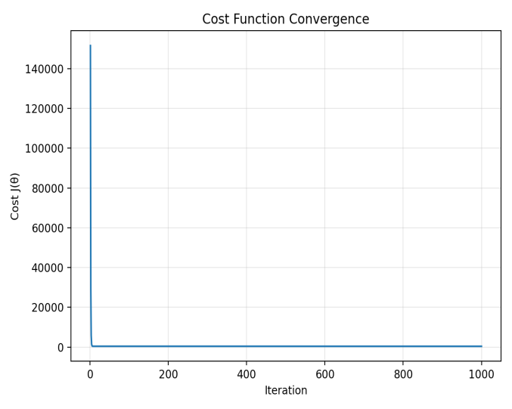  Fig.2 Cost Function Convergence

4. Methodology
- Data Collection: Used brazilianhouses.csv dataset.
- Feature Selection: Chose relevant columns – city, rooms, bathrooms, parking, fire insurance, furniture, rent amount.
- Data Preprocessing:
  - Removed currency symbols and converted text to integers.
  - Encoded furniture column using LabelEncoder.
  - Checked for and handled missing values.
- Model Training:
  - Split data into 80% training and 20% testing sets.
  - Trained model using LinearRegression() from sklearn.
- Evaluation:
  - Predicted values using test data.
  - Computed MSE and accuracy score.
- Visualization:
  - Created scatter plot comparing actual vs predicted rent values.

5. Results:

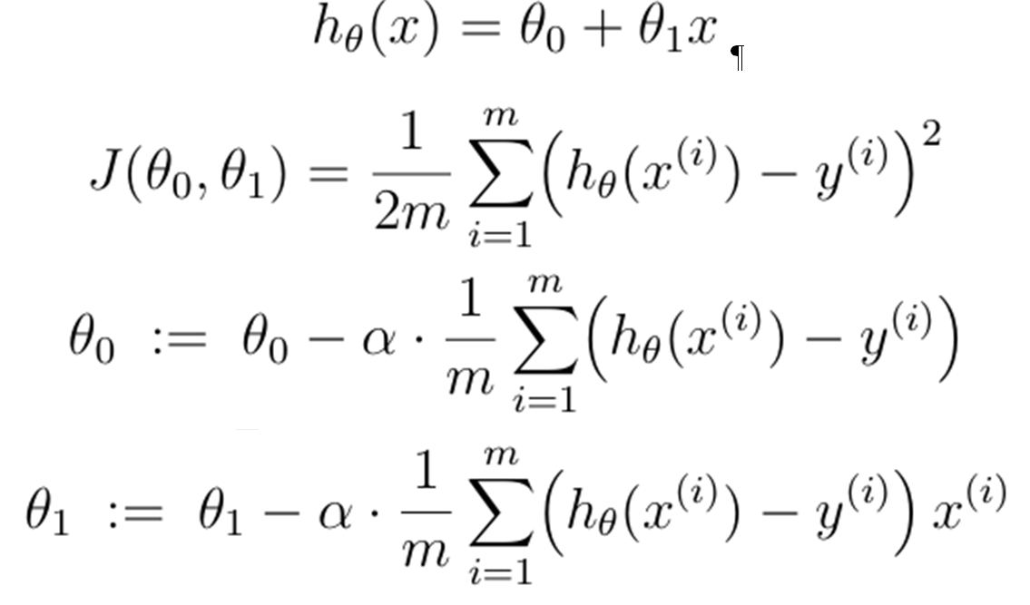

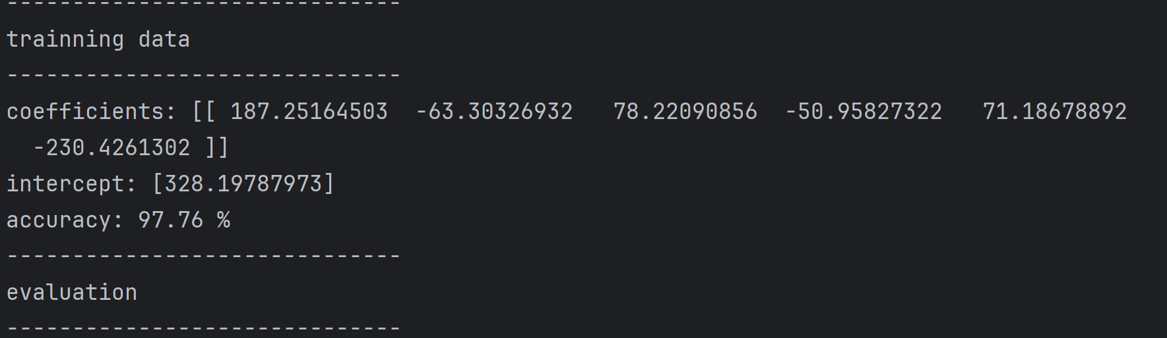

6. Discussion
The implementation exactly matches the lecture equations using explicit summed gradients for θ₀, θ₁. Batch gradient descent with a small α converges slowly but is numerically stable for this simple uni-variate dataset. The normal equation provides a closed-form solution that often gives similar slopes but can differ in intercept due to various factors (outliers, preprocessing differences, numerical precision).

7. Conclusion

The model successfully predicts house rent prices using Multivariate Linear Regression.

Found strong correlation between predicted and actual rent values.

